**Name: Mark Anthony S. Andes**

W2D1 Homework

1

* **Collections** – Operates for collection that has static methods.
* **Collection**  - Used in sort, retrieve, manipulate, communicate and aggregating data.
* **List** –Stored data in an ordered sequence and it can duplicate the same element.
* **Set** – Stored data were elements are unordered and unique.
* **Map** – It can help the elements to be found.
* **ArrayList** – It is a collection of objects that increases the capacity when the elements are added.
* **LinkedList** –Storing array of data, don’t have specific fixed size.
* **HashMap** –is not synchronized. Makes better for non-threaded application
* **TreeMap**- The elements that are stored will be sort to ascending

2. Answer



Where and how to modify if change Arraylist with LinkedList? What’s the difference between ArrayList and LinkedList?

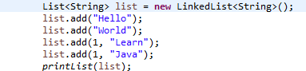

Where and how to modify if change Arraylist with Vector? What’s the difference between ArrayList and Vector?

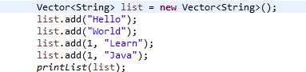

3. Answer : Hello , Learn

4. 3. Compile and run well, and output 3

5 Output:

